

Top 10 science stories

of 2010

**Some of the biggest stories of 2010 also had strong scientific elements and the New Zealand media in general rose to the occasion, going the extra mile to get sound scientific input into articles and graphics, interviews and broadcasts.**

The Science Media Centre, using media monitoring statistics from Meltwater News and its own media logs tracking coverage of SMC Alerts and Briefings, has assembled a list of the top 10 science-related stories attracting media coverage during the year.

Many of the stories below were long-running and multifaceted and involved issues that will be on the media agenda for years to come.

The graphics in the appendices monitor science-related terms in the media to give an indication of how coverage of science-related stories tracked during the year.

1. **Canterbury shows its resilience**

**The 7.1 magnitude Canterbury earthquake of September 4 was the biggest story of national interest during the year – bar none.**

The quake caused billions of dollars damage in Christchurch and smaller settlements such as Kaiapoi, hugely disrupted business in the region and traumatized a population that continues to cope with numerous aftershocks.

Not surprisingly, the Canterbury quake as a news story yielded numerous scientific angles that the media seized on from the outset. The earthquake was notable for the fact that it was caused not by a rupture of the Alpine fault line which runs along the backbone of the South Island, but a previously hidden fault beneath the Darfield and Rolleston areas.

New Zealanders quickly became familiar with the phenomenon of liquefaction, which caused major damage to homes. In the wake of the quake, scientists began to look at whether the earthquake would have any impact on the Alpine fault line or other faults, whether the earthquake could be part of a cluster of large quakes and what we could learn from the quakes to avoid loss of life and limit damage in future.

As iconic but unstable buildings in Christchurch were pulled down, engineers looked at how unreinforced masonry crumbled in the quake, non-structural damage took its toll on houses and roads, bridges and underground infrastructure buckled and twisted. The quake served as a reminder of New Zealand’s precarious position on the edge of the Pacific Ring of Fire and the role science plays in helping us better understand the risks we live with.

**Quality of coverage:** **Excellent**

**From the SMC:**

**SMC Alert:** [**Professor Euan Smith on lessons from the quake**](http://www.sciencemediacentre.co.nz/2010/09/06/professor-euan-smith-on-lessons-from-the-quake/)

**SMC Alert:** [**The psychological impacts on Canterbury quake victims**](http://www.sciencemediacentre.co.nz/2010/09/09/expert-on-psychological-impacts-on-canterbury-quake-victims/)

**SMC Briefing:** [**How earthquake resilient are our cities?**](http://www.sciencemediacentre.co.nz/2010/12/09/how-earthquake-resilient-are-our-cities/)

**Sciblogs:** [**Haiti 230,000 deaths. Canterbury 0 deaths. Why?**](http://sciblogs.co.nz/shaken-not-stirred/2010/09/06/haiti-230000-deaths-canterbury-0-deaths-why-canterbury-earthquake-pt-i/)

1. **Pike River mining disaster**

**Another disaster, another front page story and another example of where the media looked to science to help make sense of events.**

The Pike River mine explosion captured the public’s attention for the best part of ten days and saw the media throw resources into Greymouth reminiscent of the way rolling coverage of the Canterbury quake was run.

Initially, the focus of the media’s attention at Pike River was on the effort to rescue the missing miners and numerous scientists stepped up to provide commentary on mining engineering, the make-up of gases in the mine and the dangers posed by coal seam methane.

Later as the rescue efforts intensified, experts weighed in on rescue robots and the CCTV footage that emerged showing the long tail of the blast within the mine. As hope faded and then was extinguished with the second massive mine explosion, scientists outlined what would be necessary to make the mine safe enough to enter to remove the miners’ bodies – namely, the deployment of the GAG jet engine unit and the “inertization” of the gases in the mine.

**Quality of coverage:** **Excellent**

**From the SMC:**

**SMC Alert:** [**Mine CCTV footage – what it may tell us**](http://www.sciencemediacentre.co.nz/2010/11/24/mine-cctv-footage-what-it-may-tell-us/)

**SMC Alert:** [**Effectiveness of robots in mine rescue efforts**](http://www.sciencemediacentre.co.nz/2010/11/23/experts-on-effectiveness-of-robots-in-mine-rescue-operations/)

**SMC Alert:** [**Experts on explosion, conditions in the mine, rescue effort**](http://www.sciencemediacentre.co.nz/2010/11/22/pike-river-experts-on-explosion-conditions-in-the-mine-rescue-efforts/)

1. **Vine disease hits kiwifruit**

**The PSA disease was the biggest biosecurity issue New Zealand had to respond to during the year.**

News that the devastating vine disease was present on kiwifruit orchards in the Bay of Plenty was met with alarm by the industry and as the number of infected orchards grew, it became obvious from the scientific detail emerging about PSA that there was unlikely to be any cure for the disease.

Orchards set about burning infected vines and doing their best to limit the damage, as the Government and kiwifruit industry established a fund to help pay for the biosecurity effort and clean-up.

The story slipped off front pages as it became clear New Zealand kiwifruit was unlikely to be denied access to markets and then, rather suddenly, coverage of Pike River took priority. Science-related questions that have emerged from the PSA outbreak centre around how the disease spreads, how we cope with it long term and what we can learn from the outbreak to inform our biosecurity efforts. However, these questions remain largely unaddressed by the media.

**Quality of coverage: Mediocre**

**From the SMC:**

**SMC Backgrounder:** [**PSA and kiwifruit – scientific backgrounder**](http://www.sciencemediacentre.co.nz/2010/11/15/psa-and-kiwifruit-scientific-backgrounder/)

1. **Mining the conservation estate**

**One of the most controversial science-related stories of the year focused on a proposal to open up parts of the national conservation estate to mining.**

Ultimately the plans were shelved in the face of public opposition, but as public submissions to the government on the issue piled up, numerous science-related angles – from the feasibility of “surgical” mining methods to the potential impact of mining on biodiversity, were tackled by the media.

Many of the stories centered on the difficulty of accurately estimating New Zealand’s potential mineral wealth and, more importantly, how to extract it without scarring the landscape and causing the type of environmental damage previous New Zealand mining efforts have.

Claims that mining in parts of the North Island could spell the end of the endangered Archey’s frog came to symbolize the opposition to the mining from environmentalists, though scientists also shared concerns about the potential impact on wider biodiversity that might result from mining.

**Coverage:** **Good**

**From the SMC:**

**SMC Briefing:** [**Sustainable mining – scientists weigh in**](http://www.sciencemediacentre.co.nz/2010/04/30/sustainable-mining-scientists-weigh-in/)

1. **Lowering the blood alcohol limit**

**Debate raged throughout the year over whether the blood alcohol limit for drivers should be lowered in an effort to reduce deaths and serious injuries resulting from accidents caused by drunk drivers.**

The media seized on the fact that existing scientific evidence and public opinion were overridden in the debate in favour of political will to defer the decision for two years while further New Zealand-centric research was carried out.

Media stories also examined the fact, by way of numerous non-scientific experiments involving reporters and large amounts of alcohol, that many people are able to consume relatively large amounts of alcohol and stay within the legal blood alcohol limit. Professor Doug Sellman, of the National Addiction Centre at the University of Otago, was at the forefront of scientific discussion of the issue, but was also accused of crossing from science into activism for his fierce criticism of the alcohol industry. Professor Sellman ended up being nominated for New Zealander of the Year by the New Zealand Herald for his stance on the issue.

**Coverage:** **Good**

**From the SMC:**

**SMC Briefing:** [**The science on blood alcohol limits**](http://www.sciencemediacentre.co.nz/2010/04/08/blood-alcohol-limit-50-vs-80-what-impact-for-drivers/)

**SMC Infographic:** [**50 vs. 80 – what impact for drivers?**](http://www.sciencemediacentre.co.nz/2010/04/08/blood-alcohol-limit-50-vs-80-what-impact-for-drivers/)

1. **Clamping down on tobacco**

**Another major public health issue was put on the agenda when Parliament's Maori Affairs select committee released a report calling for measures to halve the overall smoking rate by 2015 and make New Zealand smoke-free by 2025.**

The report’s release followed the publication of new research from public health scientists at the University of Otago which called for nearly all smoking to be snuffed out over the next decade by the government imposing increasingly tight limits on the supply of commercial tobacco.

Otago researchers also found in a separate study that graphic images of the effects of smoking on cigarette packages deter young adults from smoking. They suggested that the size of graphic images on cigarette packages should be increased. During the period smoking was banned in prisons.

The Tobacco Use in New Zealand survey revealed that the number of “current smokers” – aged between 15 and 64 and smoking at least once a month, dropped between 2006 and 2009 from 24.4 per cent to 21.8 per cent.

A ban on tobacco displays in retail outlets and calls from the Maori Party for smoking in vehicles to be banned helped keep the issue on the media agenda for much of the year.

The Tobacco Use in New Zealand survey found 21.8 per cent of adults were current smokers in 2009, down from 24.4 per cent in 2006.

**Coverage:** **Mediocre**

**From the SMC:**

**SMC Alert:** [**Heavy smoking in pregnancy and criminality in offspring**](http://www.sciencemediacentre.co.nz/2010/11/16/experts-on-heavy-smoking-in-pregancy-and-crime-in-offspring/)

**SMC Podcast:** [**David Nutt – the inconvenient truth about drugs**](http://www.sciencemediacentre.co.nz/2010/08/06/professor-david-nutt-the-inconvenient-truth-about-drugs/)

1. **Intensive farming in the MacKenzie Basin**

**A controversial plan by three firms to set-up large-scale cubicle farms for up to 18,000 cows in the South Island’s MacKenzie Country put environmental and sustainability issues squarely in the media spotlight early in the year.**

Applications by the firms to discharge effluent into the MacKenzie Basin were eventually withdrawn, but not before the Government took the unusual step of “calling in” the applications for consideration and put the issue out to public consultation.

Along with the mining proposal, the intensive farming proposal was one of the defining environmental issues of the year, going to the heart of New Zealanders’ values when it comes to land-use and our perception of our own “clean, green” image.

Science-related angles looked at the impact of effluent discharge from a large number of cows, the impact of intensive farming on the fragile MacKenzie Basin tussock grasslands and the sustainability of intensive farming versus traditional pasture farming.

**Coverage:** **Good**

**From the SMC:**

**SMC Briefing:** [**What’s in our groundwater?**](http://www.sciencemediacentre.co.nz/2010/08/25/whats-in-our-groundwater/)

1. **Water quality and our rivers**

**Water management and the quality of our freshwater sources received extensive coverage during the year as concerns around so-called “dirty dairying” were aired and the Government moved to take control of water management in Canterbury by sacking the board of Environment Canterbury.**

The ECAN woes put into sharp relief the complexities of sustainable long-term water management strategies, which later in the year became the focus on the Land and Water Forum’s report *A Fresh Start for Fresh Water*. The well-received report released in September looked at ways to better protect our waterways from pollution and how to deal with the increasing demands on a scare resource – fresh water.

If the report took an optimistic tone, acrimony often characterized the debate between the dairy industry and environmentalists, particularly in the wake of the release of a report on progress under the Dairying and Clean Streams Accord issued today by the Ministry of Agriculture and Fisheries (MAF). The report sharply criticised dairy farmers who are failing to meet agreed targets for controlling pollution.

Scientific angles focused on the monitoring of water quality in our waterways with extensive discussion continuing into the new year of a report released late in 2009 that suggested the Manawatu River was among the dirtiest of 300 tested in the Western world.

The report, undertaken by the Cawthron Institute found the river was polluted with treated sewage, industrial waste and farm runoff. While aspects of it were disputed by the Horizons Regional Council in a scientific briefing held later in the year, ecologists conceded that the river was among the most polluted in the country, a view backed up by Ministry for the Environment scientific indicators.

**Coverage:** **Good**

**From the SMC:**

**SMC Briefing:** [**Polluted waterways – the science and the solutions**](http://www.sciencemediacentre.co.nz/2009/06/07/polluted-waterways-the-science-and-the-solutions/)

**SMC Briefing:** [**What is in our groundwater?**](http://www.sciencemediacentre.co.nz/2010/08/25/whats-in-our-groundwater/)

**SMC Alert:** [**Dairying and Clean Streams Report highlights increasing pollution**](http://www.sciencemediacentre.co.nz/2010/03/18/dairying-and-clean-streams-report-highlights-increasing-pollution/)

1. **“Australia-sized” storm heads for New Zealand**

**As Cantabrians were clearing the rubble from there quake-damaged streets, a storm considered at one stage by meteorologists to be as large in geographic spread as the continent of Australia bore down on the country.**

When the storm did hit it brought down power lines leaving thousands of people the length of the country in the dark, tore roofs off houses and collapsed the roof of an Invercargill stadium.

Experts were taken aback at the sheer size of the storm front, which at the time was one of the largest on the planet.

**Coverage:** **Mediocre**

1. **The “powder keg” of youth**

**The Prime Minister’s Chief Science Advisor, Professor Sir Peter Gluckman released a briefing paper during the year as part of a major project that is looking at what he called the “tragic behaviours” that too often lead to the deaths of adolescents.**

Reflecting on the tragic deaths of two Auckland teenagers in separate incidents of misadventure, Sir Peter said the underlying causes of adolescent behaviour and the possible solutions to the problem would be examined as part of a project requested by the Prime Minister.

The project would focus on three areas of adolescent development - increased rate of sexual maturation, a slow rate of neural maturation, and an increasingly complex social milieu.

Science-based discussion of Sir Peter’s paper focused on the gap between sexual maturation and maturation of the brain. Numerous stories during the year, some based on new research papers, examined the impact technologies such as mobile phones and social networking websites are having on adolescent behavior.

**Coverage:** **Good**

**Other science-related stories of significance in 2010**

**Rare double earthquake caused Pacific tsunami**

**SMC Briefing:** [**Experts on Nature research on double earthquake**](http://www.sciencemediacentre.co.nz/2010/08/19/7496/)

**Light trap for single atom devised**

**SMC Alert:** [**Experts on atom breakthrough**](http://www.sciencemediacentre.co.nz/2010/09/27/light-trap-for-single-atom-devised/)

**Craig Venter’s synthetic cell breakthrough**

**SMC Alert:** [**Experts on Craig Venter’s breakthrough**](http://www.sciencemediacentre.co.nz/2010/05/21/experts-on-craig-venters-synthetic-biology-breakthrough/)

**Cancun – climate negotiations step up**

**SMC Alert:** [**Experts on ‘Cancun Agreements’**](http://www.sciencemediacentre.co.nz/2010/12/13/cancun-agreements-emerge-from-cop16-talks-experts-respond/)

**2010 - Year of biodiversity**

**SMC Briefing:** [**What’s in the sea? Census of Marine Life**](http://www.sciencemediacentre.co.nz/2010/08/03/whats-in-the-sea-census-of-marine-life-marine-biodiversity-roll-call/)

**SMC Briefing:** [**Biodiversity in 2010 – taking stock**](http://www.sciencemediacentre.co.nz/2010/12/03/online-briefing-biodiversity-in-2010-taking-stock/)

**What’s behind whale strandings?**

**SMC Briefing:** [**Whale strandings – what science can tell us**](http://www.sciencemediacentre.co.nz/2010/10/20/whale-strandings-what-science-can-tell-us/)

**The “Unfortunate Experiment” revisited**

**SMC Podcast:** [**Professor Linda Bryder on responses to ‘A History of the “Unfortunate Experiment”‘**](http://www.sciencemediacentre.co.nz/2010/08/19/professor-linda-bryder-responses-to-a-history-of-the-unfortunate-experiment/)

**Mobile phones and cancer risk**

**SMC Briefing:** [**Mobile phones and brain tumours – the Interphone study**](http://www.sciencemediacentre.co.nz/2010/05/18/mobile-phones-and-cancer-risk-experts-respond/)

**SMC Infographic:** [**Common sources of radiation**](http://www.sciencemediacentre.co.nz/2010/05/18/mobile-phones-and-cancer-risk-experts-respond/)

**Climate science and “Glaciergate”**

**SMC Alert:** [**IPCC – Cherish it, tweak it, scrap it?**](http://www.sciencemediacentre.co.nz/2010/02/11/ipcc-cherish-it-tweak-it-scrap-it-scientists-respond/)

**SMC Backgrounder:** [**Review backs IPCC, calls for greater transparency**](http://www.sciencemediacentre.co.nz/2010/07/07/latest-review-backs-ipcc-report-findings-calls-for-more-transparency/)

**Japanese space capsule landing in Australian outback**

**AusSMC Alert:** [**Particles from asteroid found**](http://www.aussmc.org/2010/11/rapid-roundup-hayabusa-update-particles-found-are-from-an-asteroid-experts-respond/)

**The rise of superbugs in New Zealand**

**SMC Alert:** [**Medical tourism increasing spread of superbug gene**](http://www.sciencemediacentre.co.nz/2010/08/11/medical-tourism-increasing-spread-of-superbug-gene/)

**Confusion over vitamin D**

**SMC Alert:** [**New UK consensus on vitamin D – experts respond**](http://www.sciencemediacentre.co.nz/2010/12/17/new-uk-consensus-on-vitamin-d-experts-respond/)

**Arsenic-eating bacteria discovered on Earth**

**SMC Alert:** [**Experts on NASA astrobiology discovery**](http://www.sciencemediacentre.co.nz/2010/12/03/arsenic-eating-bacteria-expand-scope-of-what-life-could-be/)

**Scientists plan to drill deep into Alpine Fault**

**Govt R&D voucher scheme and science spending in the Budget**

**NIWA’s climate data questioned**

**Japanese and the “scientific” case for whaling**

**New Zealand’s role in the Global Research Alliance**

**The ‘debunking’ of the food miles argument**

**Scientists plan human genes for cows, goats**

**Science-related stories before the Press Council and BSA**

**It was a relatively quiet year for science-related Press Council complaints with climate change and complaints about coverage of the “Unfortunate Experiment” dominating the Press Council’s business in this area.**

The New Zealand Listener and the New Zealand Herald were both the subject of complaints for their coverage in the wake of the release of Professor Charlotte Paul’s controversial book. Neither complaint was upheld.

The Herald and the Listener again were under fire for their coverage of climate change. While one complaint against the Listener that dealt with coverage of the Copenhagen climate discussions of December 2009 was not upheld, a separate complaint aimed at the Herald’s description of greenhouse gas emissions was upheld.

The Broadcasting Standards Authority heard complaint about a small number of science-related items, including a complaint against TVNZ for its coverage of the New Zealand Sceptics Society’s high-profile attempt to overdose on homeopathic remedies. The complaint, which argued that the Close Up piece “had not presented significant points of view or the relevant facts” was not upheld.

A *Close Up* interview with scientist and prominent atheist Richard Dawkins also sparked a BSA complaint that was not upheld on all counts.

TVNZ programmes Q&A, Close Up and One News were also the subject of a complaint from the New Zealand Organisation for Rare Disorders over their treatment last year of the issue of fortification of bread with folic acid. The complaint was not upheld.

A complaint against One News for claims made about non-stick cookware and potential health issues resulting from its use was partially upheld on the basis that the piece “contained misleading and inaccurate statements – would have unnecessarily alarmed viewers”.

**Press Council and BSA rulings:**

**Press Council:** [**North & South and the Antarctic toothfish**](http://www.presscouncil.org.nz/display_ruling.php?case_number=2143)

**Press Council:** [**New Zealand Listener and the “Unfortunate Experiment”**](http://www.presscouncil.org.nz/display_ruling.php?case_number=2110)

**Press Council:** [**The New Zealand Listener and anthropogenic global warming**](http://www.presscouncil.org.nz/display_ruling.php?case_number=2109)

**Press Council:** [**The New Zealand Herald and carbon dioxide equivalents**](http://www.presscouncil.org.nz/display_ruling.php?case_number=2108)

**Press Council:** [**The New Zealand Herald and the “Unfortunate Experiment”**](http://www.presscouncil.org.nz/display_ruling.php?case_number=2145)

**BSA:** [**Close Up and Professor Richard Dawkins**](http://www.bsa.govt.nz/decisions/2010/2010-062.htm)

**BSA:** [**Close Up and homeopathy skeptics**](http://www.bsa.govt.nz/decisions/2010/2010-049.htm)

**BSA:** [**One News and non-stick cookware**](http://www.bsa.govt.nz/decisions/2006/2006-021.htm)

**BSA:** [**Q + A, Breakfast, Close Up and One News on folic acid fortification**](http://www.bsa.govt.nz/decisions/2009/2009-131.htm)

**Appendix I**

**The graph below tracks general coverage of science, technology, research organizations, agriculture and climate change in the Year to September 30 in major New Zealand electronic news sources.**

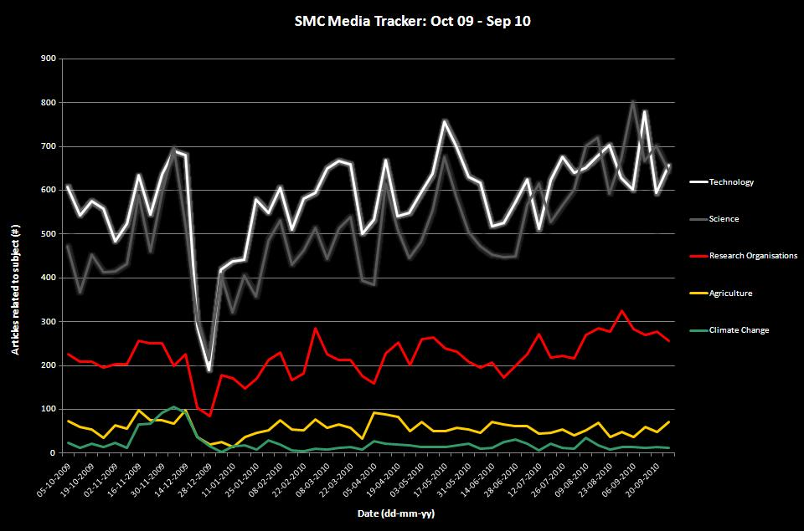

*Source: Meltwater media tracking*

**Appendix II**

**The graph below looks at three major science-related stories in 2010 and how coverage of these stories by volume of stories compared.**

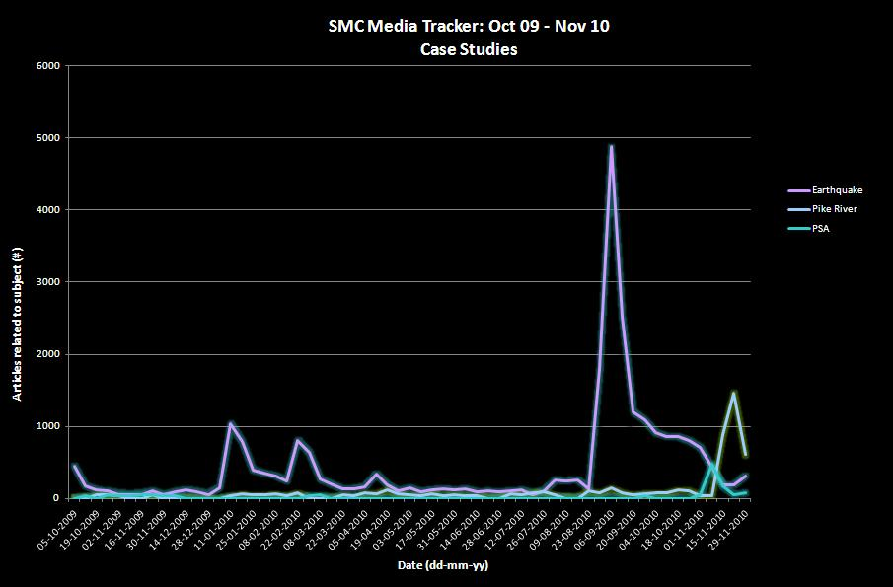

*Source: Meltwater media tracking*

**Appendix III**

With the Government’s increased focus on innovation and research and development during the year, did media coverage of these issues increase? The graph below tracks references in the year to September 30, 2010 to “innovation” and “research and development”.

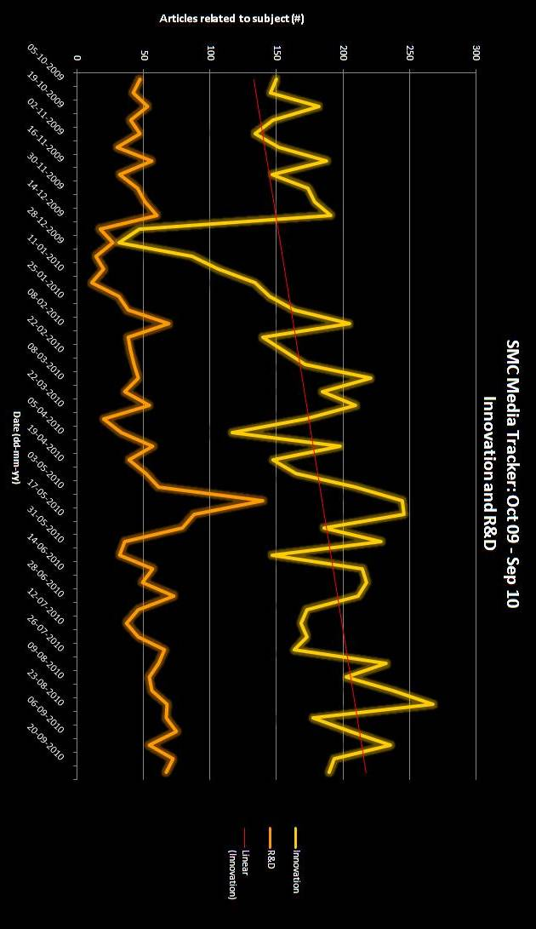

**Disclaimer:**

The SMC Media Tracker is meant to be indicative only, with its primary purpose being to pick up and highlight trends in topics over time – due to measuring only the online media landscape and the technology used to measure article numbers, it cannot be said to be definitive.

Out now! The ***SMC Desk Guide for Covering Science*** – more info at www.sciencemediacentre.co.nz/deskguide

